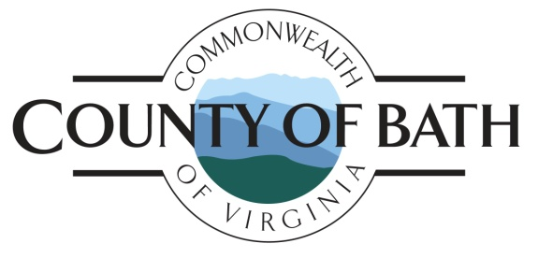

COUNTY OF BATH, VIRGINIA
BATH COUNTY BOARD OF SUPERVISORS
BATH COUNTY COURTHOUSE – ROOM 115
Tuesday, December 13, 2022 – 6:00 p.m.

6:00 p.m. Regular Meeting Agenda
- Call Meeting to Order
- Pledge of Allegiance
- Moment of Silence

- Approve or Modify the Agenda

- Approve Minutes from November 8, 2022 Board of Supervisors Meeting

- Public Comment

- Chairman’s Report

- Board Member Comment

- Bath County Schools Hiring Authorizations for 2023-2024 School Year

- Board vote on Short-Term Rental Ordinance

- Board to Consider Childcare Vendor Proposals

- Revise FY 2023- 2024 Budget Calendar

- Consent Agenda
  - Payment of December invoices
  - Transfer and Appropriation Requests
  - Correspondence and Monthly Reports
  - Additional Items if needed

11. Meeting Adjournment

12. Upcoming Meetings – January 11, 2023 – Board of Supervisor's Regular Monthly Meeting. Bath County Courthouse Room 115 at 6 p.m.

Public Comment Rules and Guidelines
Citizens who desire to speak in the public comment session at the beginning of the Board meeting must sign in to be recognized by the Chairman, and adhere to the following:
- Individuals should come forward to the podium when recognized by the Chairman of the Board; speak their name and address or district in which they reside.
- Individuals should direct their comments to the Chairman of the Board.
- Individuals are limited to 3 minutes per comment period.
- Individuals representing a group of four or more are limited to 5 minutes per comment period, members comprising the group represented forfeit their individual time to speak.
- All citizens are strongly encouraged to put their comments in writing to the Board prior to the meeting for inclusion in the Board materials. Such written comments should be submitted to the County Administrators Office or to a member of the Board of Supervisors the Thursday prior to the meeting. Comments can be submitted via email at publiccomment@bathcountyva.org.

